**CCT College Dublin**

**Assessment Cover Page**

| **Module Title:** | Web Development |
| --- | --- |
| **Assessment Title:** | CA1: Develop a responsive web application, optimised for mobile, tablets and desktop devices |
| **Lecturer Name:** | Hugh McGovern |
| **Student Full Name:** | Kavi Patak |
| **Student Number:** | sba22391 |
| **Assessment Due Date:** | 22 March 2023 |
| **Date of Submission:** | 22 March 2023 |



**Declaration**

| By submitting this assessment, I confirm that I have read the CCT policy on Academic Misconduct and understand the implications of submitting work that is not my own or does not appropriately reference material taken from a third party or other source. I declare it to be my own work and that all material from third parties has been appropriately referenced. I further confirm that this work has not previously been submitted for assessment by myself or someone else in CCT College Dublin or any other higher education institution. |
| --- |

Based on my knowledge of the Software Development Life Cycle, I decided to take an Agile approach to the scenario, implementing both throw away and evolutionary prototyping processes. In order to successfully implement this approach, I will be treating the assignment brief as the core functionality, following a first round of requirements gathering with stakeholders. I will be working under the assumption that further stakeholder feedback and evaluation will be provided throughout the development process in order to progress our prototype and the overall application.

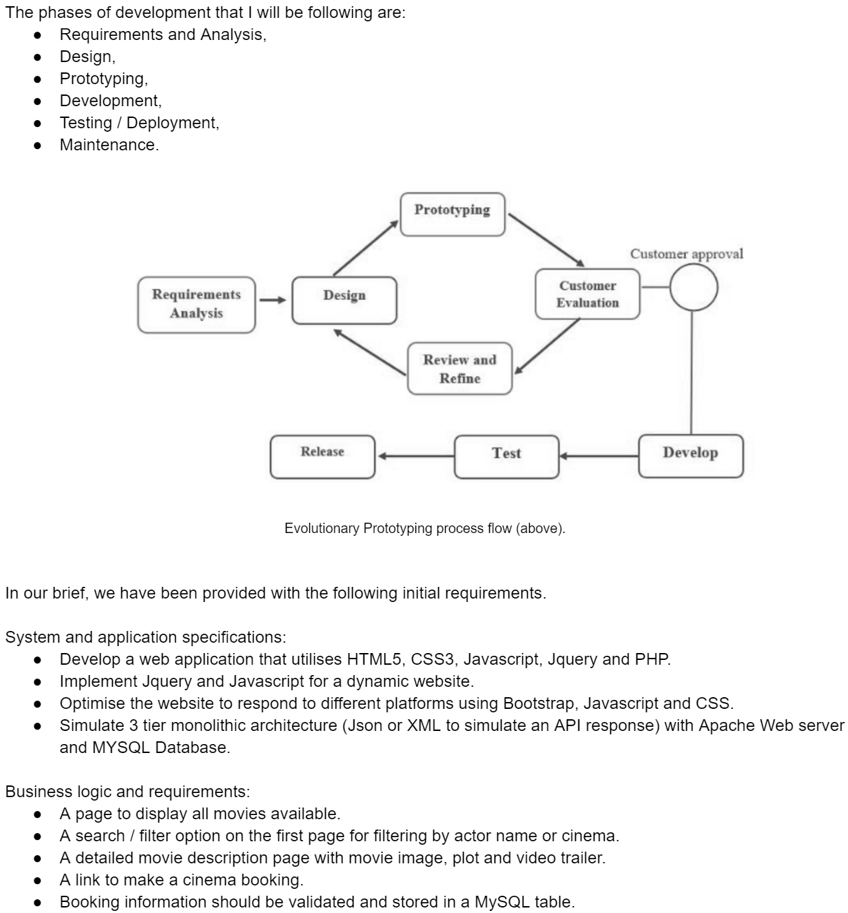

Naturally, all the above can be implemented in a variety of ways. So before commencing on a potentially endless design phase, I decided to conduct further research and competitor analysis to familiarise myself with the current market and its trends. Typically this step, along with content planning and design would be carried out in collaboration with key stakeholders.

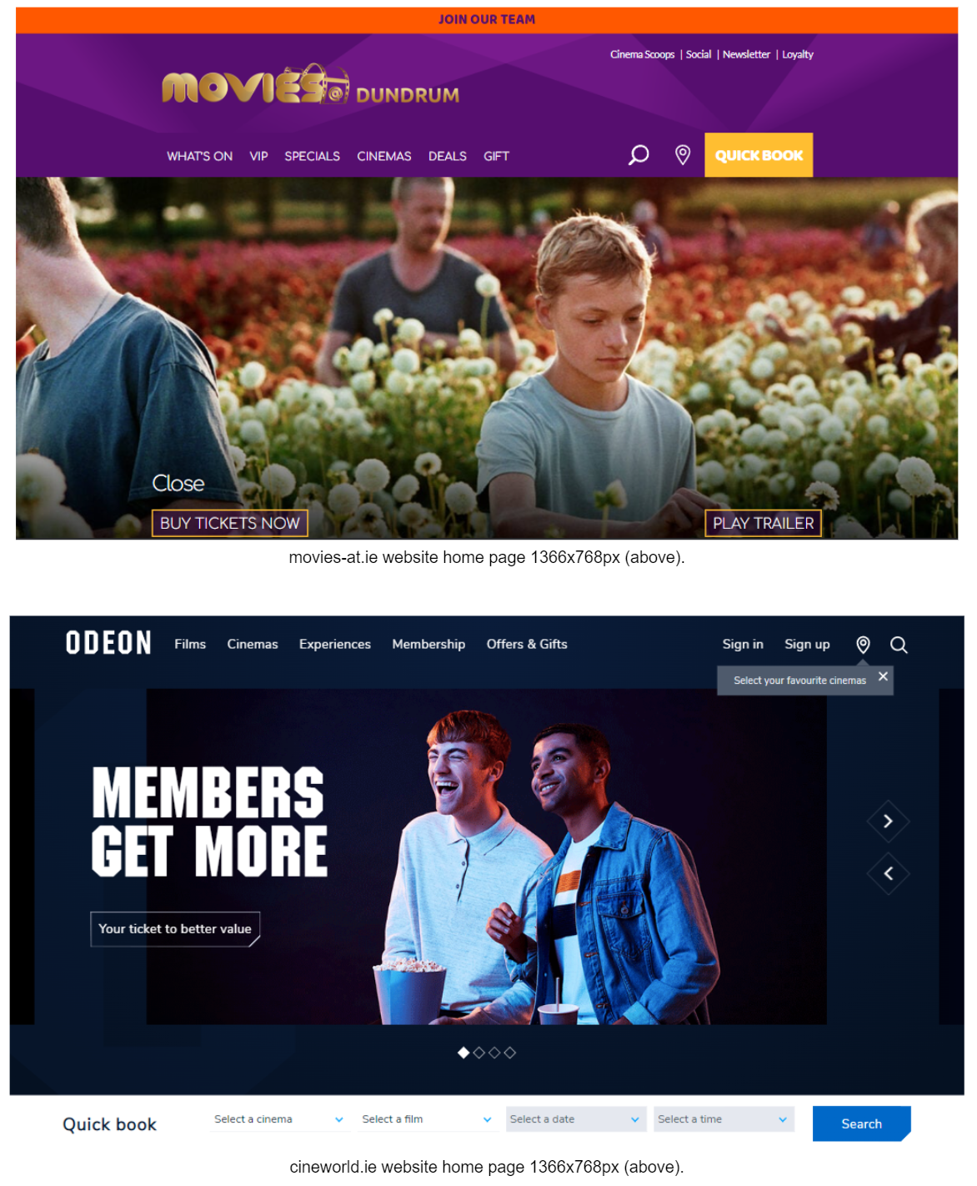

As evident from the above examples, a true and comprehensive cinema website would include considerably more user options and functionality like members login, discounts and promotions, an about and contact page, and so on. Further requirements gathering should be conducted with stakeholders and with the use of scenario based tools like user case stories, user journeys and interviews. Ultimately though, a cinema website's main purpose is to provide visitors with information on current movie listings and allow for quick and easy booking of tickets, which we will be focusing on for our initial prototypes. Most cinema websites I visited catered to this, with movie listings immediately visible, sticky search bars and quick book options, as seen in the examples. The website that stood out to me was Omniplex Cinema, with its simple layout and design, utilising clear typography for easy site navigation.

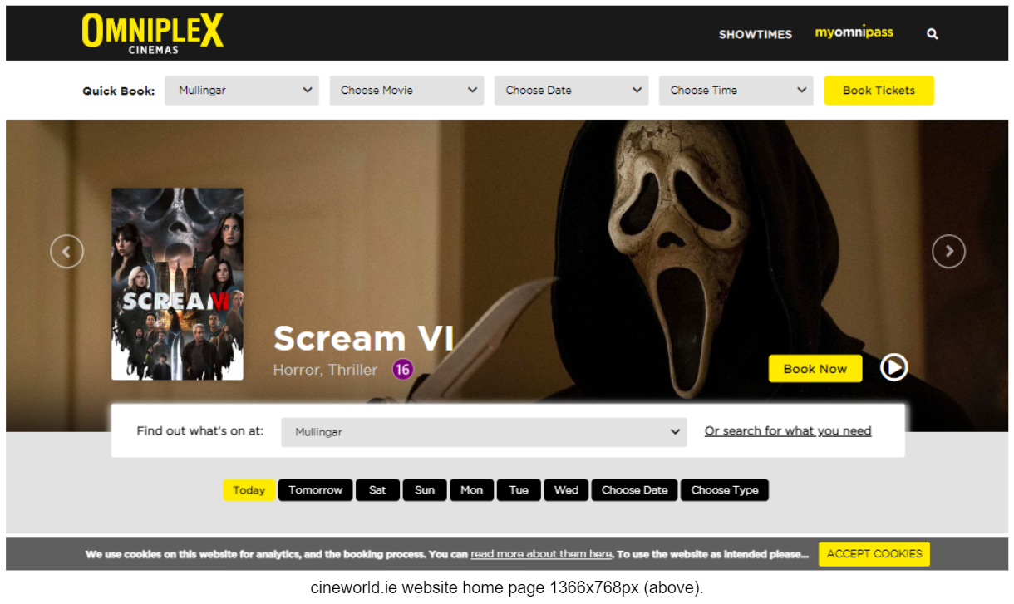

Additional steps considered in the planning phase were the Information architecture of the site, would it follow a broad or deep hierarchy, and the classification scheme most appropriate. I opted for a task based scheme to include; Search Listings, Movie Overview and Book tickets, implementing our core requirements. Our site map is therefore relatively simple and somewhat predetermined by our project specifications and requirements. An example of our site map diagram can be seen below. Again, with further requirements gathering and stakeholder feedback, the site could potentially grow as illustrated in our second site map diagram. An XML sitemap has also been generated and included to assist web crawlers in navigating our site for Website Indexation in Search Engine Optimization(SEO). To complete the process we would need to register our site with the search engines of our choice.

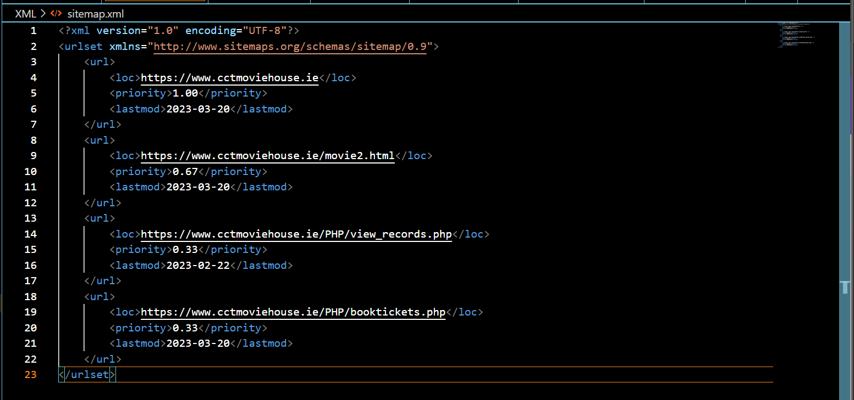

XML sitemap for our website (above).

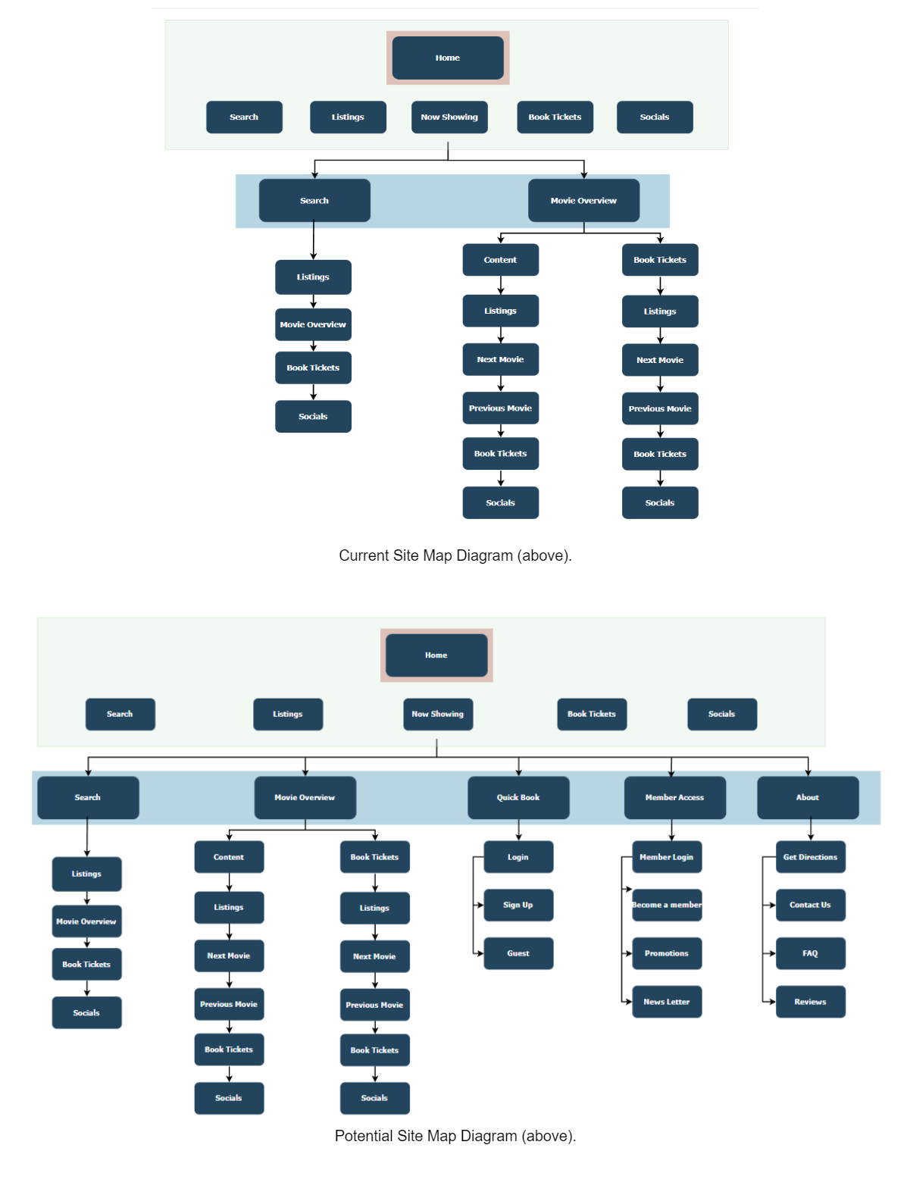

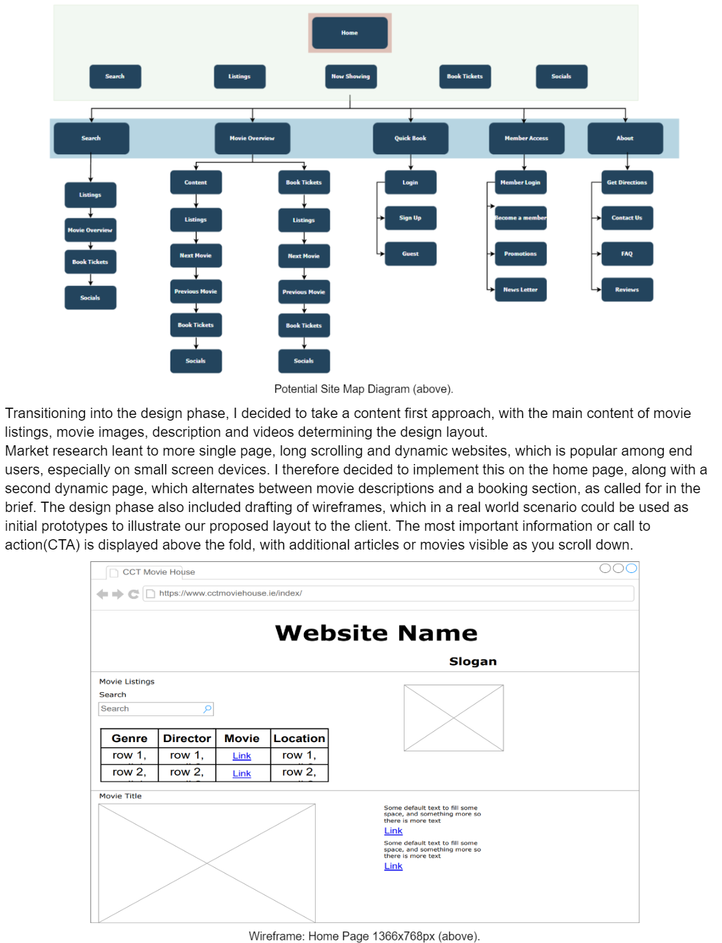

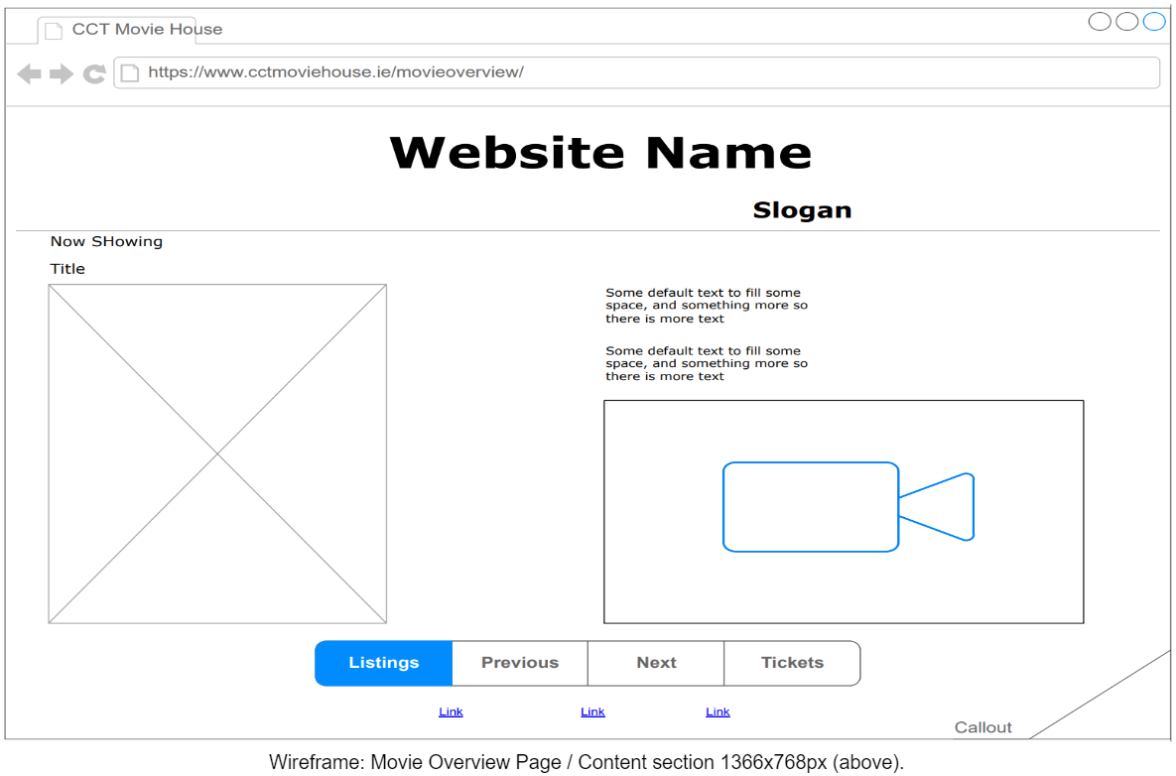

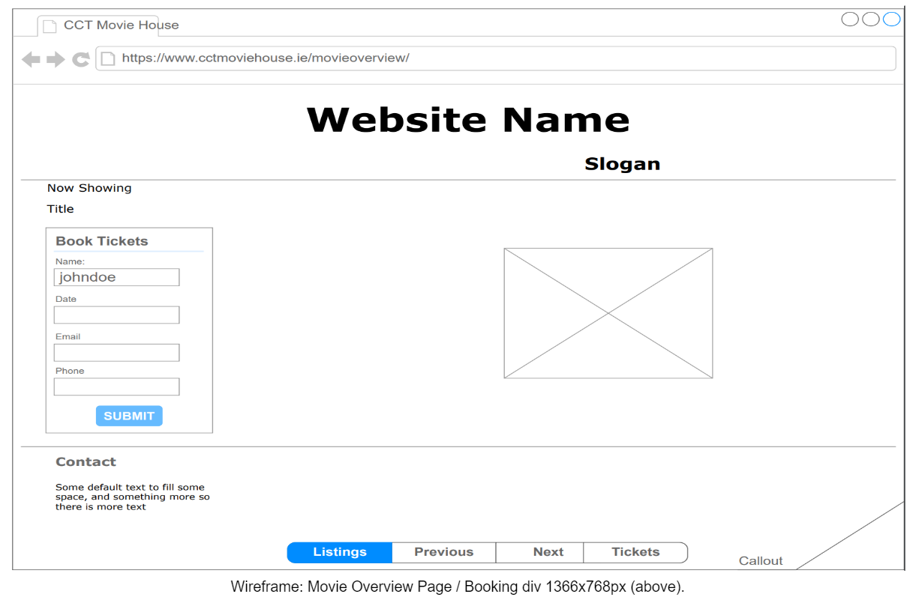

The next part of the design phase, which is typically influenced by stakeholder input, existing branding, target audience and personal preference, is the theme or colour scheme of the user interface(UI). Branding is incredibly important for a number of reasons, not only for distinguishing yourself from competitors or establishing a reputation, but because it would impact all future marketing endeavours, including the style, theme and colour choices for our website. In a real life scenario, one would usually revert to the client with a few visual design prototypes to get a feel for their preferences and direction. As I have been granted creative freedom in our scenario, I decided to implement a retro, high contrast, sci-fi theme, based around CCT College conducting student movie nights.

The Developmental phase is responsible for bringing all the planning and design to life. As specified in the brief, HTML5, CSS3, Javascript, Jquery and Bootstrap were all used in the development of the front end of our website.

HTML5 being a HyperText Markup Language was used for the majority of our front end code, to layout and display text and images on our website. CSS3 was used to style these HTML elements, implementing both inline and external styling, with separate CSS3 style sheets used for each of our HTML pages. In addition to our use of CSS3, Bootstrap’s grid system was utilised to easier place and position our divisions, and to implement responsive design features for different devices. A filter/ search feature was implemented with the use of Jquery to indirectly access an XML document containing the current movie listing details, to filter through them, and to populate our listings table in real time. Jquery being a Javascript library which allows the implementation of javascript code in fewer lines thanks to its precoded existing functions. XML which stands for Extensible Markup Language lets you define and store data in a shareable manner. It is both human and computer readable, and supports information exchange between computer systems such as websites and databases. Implementing Jquery and XML in this way creates a dynamic aspect to our page, speeding up the transition process by removing the need to query the server. Further Javascript code was used for the dynamic elements of our Movie Overview page, alternating between visible and hidden elements in our Content and Booking sections. It is also used in aspects of our backend development. The back end of our application makes sure that all the business logic and data storage is properly implemented. Including database creation and integration, API development and integration, security and input validation. PHP or Hypertext Preprocessor is a server side scripting language that allows developers to create dynamic content and to interact with databases. Information is passed from our HTML booking form to our PHP page which in turn connects to our localhost database and transfers data to our MySQL table accordingly. Additional features like validation have been implemented with javascript as well as a confirmation email being sent on successful booking of tickets.

When selecting appropriate storage solutions for our application, it is important to consider the two types of data that we are working with, that is, input data like user information submitted in our booking form, or output data like our movie listings or booking details which we intend to display to the user. This data can either be stored temporally with short term options such as Random Access Memory (RAM) or Read-only Memory (ROM), but neither is ideal as their purpose, storage capacity and memory retention are limited. This is where long term data storage solutions come into play, allowing organisations the ability to scale, to retain large amounts of different data types securely, to organise, maintain and manipulate this data, and to implement backup and recovery plans protecting against disaster, failure or fraud.

Long term storage solutions are offered in two main categories, direct area storage or network based storage.

Direct Area Storage or Direct Access Storage (DAS) is a simple long term solution that we have implemented for our Cinema website scenario, storing data to our MariaDB server on our local storage device. A table has been created in our MySQL Database which allows us to access, update and query this data. MySQL is an open source relational database management system that uses structured query language(SQL) to organise and query the database. The GUI for interacting with MySQL is provided by phpMyAdmin via the XAMPP local server. MySQL offers excellent data structure and integration with many different platforms. It can handle large databases reliably and quickly in high-demanding environments. As previously mentioned, storing to our local device is a simple solution for our scenario, with decent local backup services, but may need to be reconsidered if we intend to have multiple users querying our database. DAS devices include floppy discs, compact discs, digital video discs, hard disc drives(HDD), flash drives and solid state drives(SSD).

A network-based storage solution however, allows multiple users access via a network, making it more suitable for data sharing and collaboration. Its ability to store data remotely, also makes it more suitable for backup and data protection. Two common network-based storage setups are Network Attached Storage (NAS) and Storage Area Network (SAN).

NAS is a file-level storage architecture that makes stored data more accessible to networked devices. It is usually a single device consisting of a redundant array of independent disks (RAID). Multiple storage devices can be connected to a SAN, including SSD and flash storage, hybrid storage, cloud storage, hybrid cloud storage, and backup software and appliances.

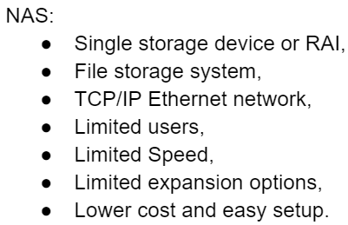 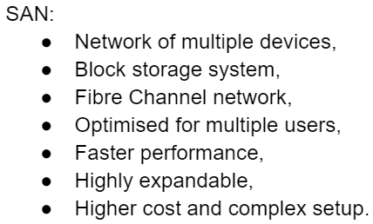

Backup storage and appliances protect against data loss due to disaster, failure or fraud. By periodically making copies of data and applications to a separate, secondary device, ensures that data is safe and that there is no single point of failure. Testing of your backup and security plans should also regularly be conducted. Secondary devices may range from HDD’s to servers, which are then used for disaster recovery and restoration. Backup storage can also be delivered as a service, also known as Backup-as-a-Service (BaaS). Cloud based storage solutions often offer this along with, hosting, managing, securing and maintaining their servers, making them an increasingly popular storage choice.

Downtime should also be considered, and steps taken to avoid it where possible. An organisation should make sure that their application is hosted on a reliable and scalable hosting platform. Load balancing can be implemented to distribute traffic across multiple servers where applicable, and perform regular maintenance such as database optimisation, file system cleaning and software updates to prevent system shortcomings. Automation tools are available for simplifying routine maintenance tasks and reducing the risk of error.

Finally, returning to our SDLC, and following the development of our front and backend, our code should be validated through a markup validation service before a working prototype can be demonstrated to our stakeholders. Feedback can be taken onboard with additional functionality added to subsequent iterations.

[**https://github.com/KaviCCT/CA1-Assignement.git**](https://github.com/KaviCCT/CA1-Assignement.git)

**Bibliography**

Vasudevan, S.K. *et al.* (2018) *Software Project Management*. Oxford, U.K.: Alpha Science International Limited.

Available at: <https://search.ebscohost.com/login.aspx?direct=true&db=e250xww&AN=2023982&site=eds-live>

(Accessed: 12 February 2023).

Adanna, A.A. and Nonyelum, O.F. (2020) ‘Criteria for Choosing the Right Software Development Life Cycle Method for the Success of Software Project’, *IUP Journal of Information Technology*, 16(2), pp. 39–65.

Available at: <https://search.ebscohost.com/login.aspx?direct=true&db=iih&AN=146061463&site=eds-live>

(Accessed: 19 February 2023).

Shriram K. Vasudevan, V.S.G.J.P.R.N. (2017) *Software Engineering*. Oxford: Alpha Science International Limited.

Available at: <https://search.ebscohost.com/login.aspx?direct=true&db=e250xww&AN=1990281&site=eds-live>

(Accessed: 7 February 2023).

Matthew Martin (2023), Prototype Model in Software Engineering, Guru99

Available at: <https://www.guru99.com/software-engineering-prototyping-model.html>

(Viewed: February 2023)..

Manifesto for Agile Software Development (2001),

Available at: <https://agilemanifesto.org/>

(Viewed: February 2023).

Lewis Coulson *et al.* (2019) *The HTML and CSS Workshop : Learn to Build Your Own Websites and Kickstart Your Career As a Web Designer or Developer*. Birmingham: Packt Publishing.

Available at: <https://search.ebscohost.com/login.aspx?direct=true&db=e250xww&AN=2322640&site=eds-live>

(Accessed: 2 March 2023).

What is Data Storage (2023), IBM,

Available at: <https://www.ibm.com/uk-en/topics/data-storage>

(Viewed: March 2023).

Content-first design: Let the content determine the design (2023), Balsamiq,

Available at: <https://balsamiq.com/learn/articles/content-first-design/>

(Viewed: March 2023).

Tips and best practices for long-scrolling websites (2021), Brainstorm Digital,

Available at: <https://brainstorm.ie/tips-and-best-practices-for-long-scrolling-websites/>

(Viewed: March 2023).

9 Types of Computer Memory Defined (2023), Enterprise Storage Forum,,

Available at: <https://www.enterprisestorageforum.com/hardware/types-of-computer-memory/>

(Viewed: March 2023).